**Smoke detection using arduino**

Introduction

`In this example, you will read the sensor analog output voltage and when the smoke reaches a certain level, it will make sound a buzzer and a red LED will turn on.

When the output voltage is below  that level, a green LED will be on.

The resistance of the sensor is different depending on the type of the gas.

The voltage that the sensor outputs changes accordingly to the smoke/gas level that exists in the atmosphere. The sensor outputs a voltage that is proportional to the concentration of smoke/gas.

In other words, the relationship between voltage and gas concentration is the following:

* The greater the gas concentration,the greater the output voltage
* The lower the gas concentration,the lower the output voltage

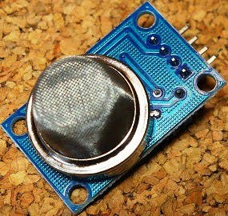[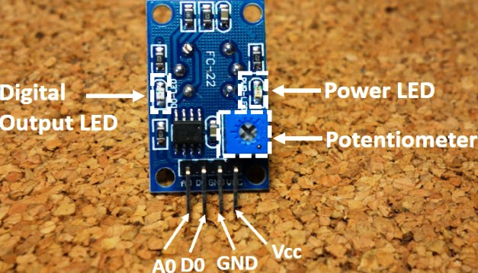](javascript:openLightBox('14d8503c0f',%200);)Components

1. Arduino Uno
2. Battery
3. Resistor
4. Smoke detector
5. Buzzer
6. Led

Objective

During this activity ,you will help students to achieve following objectives

1. Understanding the principle and operation of gas sensor

2. Design algorithm and flowchart to detect smoke and get alerted

3. Programming smoke sensor using Arduino uno

4. Interfacing smoke sensor with Arduino uno

**Programming steps**

* 1. Initialise integer variable for red and green LEDS
  2. Initialise integer variable for buzzer
  3. Initialise integer variable for smoke input data A0
  4. Initialise integer variable for threshold value of sensor
  5. Define LED & buzzer port as output port and smoke sensor as input port.
  6. Read value of analog sensor
  7. Check value of anolog sensor
  8. If analogSensor value is greater than sensor Threshold valu then red LED will get blink and buzzer rings
  9. If analogSensor value is less than sensor Threshold valu then green LED will get blink and buzzer offs

**Programming**

int redLed = 12;

int greenLed = 11;

int buzzer = 10;

int smokeA0 = A5;

// Your threshold value

int sensorThres = 400;

void setup() {

pinMode(redLed, OUTPUT);

pinMode(greenLed, OUTPUT);

pinMode(buzzer, OUTPUT);

pinMode(smokeA0, INPUT);

Serial.begin(9600);

}

void loop() {

int analogSensor = analogRead(smokeA0);

Serial.print("Pin A0: ");

Serial.println(analogSensor);

// Checks if it has reached the threshold value

if (analogSensor > sensorThres)

{

digitalWrite(redLed, HIGH);

digitalWrite(greenLed, LOW);

tone(buzzer, 1000, 200);

}

else

{

digitalWrite(redLed, LOW);

digitalWrite(greenLed, HIGH);

noTone(buzzer);

}

delay(100);

}

Hardware

Instructions.

1.Connect VCC and GND connection of MQ-2 gas sensor to 5v supply and ground pin of arduino

2.Connect analog pin Ao of sensor to the analog input pin of arduino

3.Connect positive polarity of buzzer to digital input pin 10(D10) and negative polarity to ground

4.Connect positive end of LEDS to digital input pin 11,12 (D11,D12)

